1. HTML Structure (5 Marks):
a) Create a webpage using semantic HTML elements such as <header>, <nav>, <main>, <section>, <article>, <footer>, etc.
b) Ensure that each section of the page is clearly defined and uses appropriate HTML tags to represent the content.
c) Add a navigation bar with links to different sections of the page.
d) Provide a meaningful title and meta description for SEO

a) Create a webpage using semantic HTML elements such as <header>, <nav>, <main>, <section>, <article>, <footer>, etc.
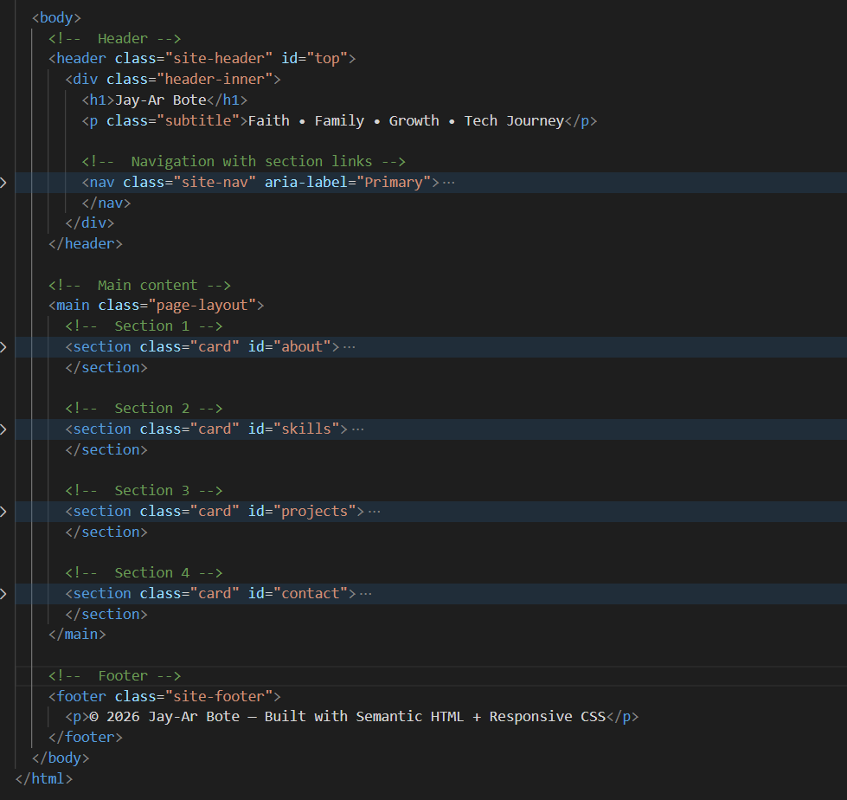

Header
|_ Nav
Main
|_ Section 1
|_ Section 2
|_ Section 3
|_ Section 4
Footer

b) Ensure that each section of the page is clearly defined and uses appropriate HTML tags to represent the content.
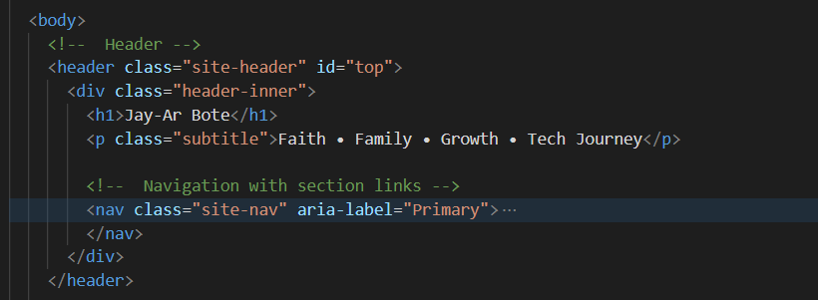

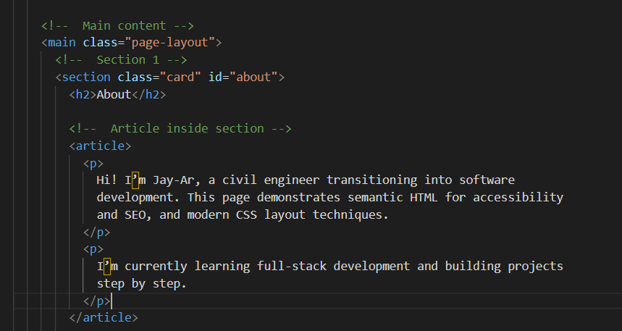
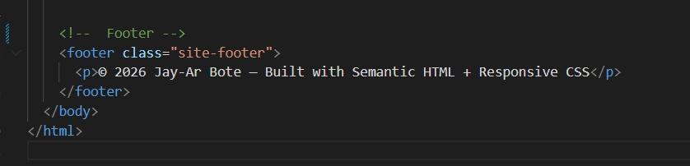

c) Add a navigation bar with links to different sections of the page.
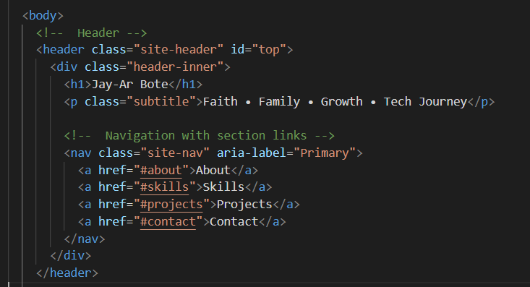

d) Provide a meaningful title and meta description for SEO
